## **ACADEMIC WRITING**

Academic writing, in general refers to expressions or styles of writing which is quite formal, objective and technical used by researchers/students to explain the territories of the disciplines and respective areas of proficiency. Since the invention of academic writing in 1864 by Plato [(Bailey 2018)](#_Bailey,_S._(2018)), a Greek philosopher, it has evolved to deliver information in intellectual manner. Academic writing discusses subject-based research questions of interest to the one who seeks objective-presented fact-based knowledge on a specific topic. The aim of academic writing is to enhance the knowledge through: study of what is currently known about a particular topic, the basis for the new views of the writer on the topic.

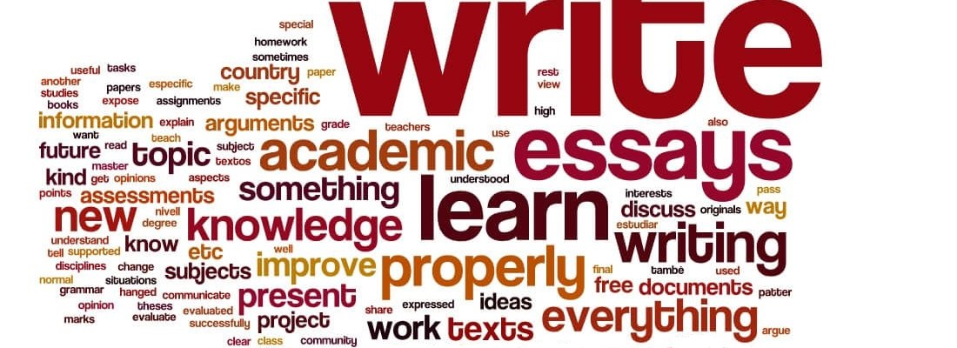

(How To Learn Academic Writing 2019)

Based on the field of study, academic writing can have different writing types and structures. For example: writing in humanities expect longer paragraphs explaining the case organization including subject sentences whereas in sciences expect short paragraphs with factual information (Writing 2019). Analytical, Critical, Descriptive and Persuasive writings are its 4 main types under which comes the reports, essays, coursework, thesis, dissertations and so on (Types Of Academic Writing 2019). Here we discuss about the coursework and dissertation in details along with the similarities and differences, their challenges and benefits.

## **CORUSEWORK AND DISSERTATION**

Coursework means tasks performed by students in school, college (University) or other educational institutions. It is the study of the predefined and preset core units which a student undertakes by attending classes, completing the tasks (homework, assignments) they are assigned along with the requirement to sit exams of modules or subjects as allocated by the authority for the full or partial fulfillment of a degree or training he/she is pursuing. (Planning Tank® 2019)

On the other hand, a dissertation is a topic that one has chosen to carry the research on. Another helpful starting point was the first use of the term in 1651 in English: ' an extended written treatment of a topic. The Latin origin of the term is another helpful indication – the thesis comes from the Latin term **“dissertare” = “to debate”** which means a discussion with distinct viewpoints or set of concepts. Consequently, a dissertation will examine not only a topic but will also consider various points of perspective. (The Royal Literary Fund 2019) Some coursework, as a part of the course may also incorporate the requirement of completing a minor thesis.

Assignments, projects, essays, field works and reports, design studies, practical works, speaking tests etc. may constitute a coursework whereas a dissertation is a substantive paper based on original research and that provides proof of the mastery of the candidate both on the topic and the scholarly method. Coursework’s nature is determined by the course itself unlike dissertation where research questions are set whether or not to agree once the writing process is completed. Just as dissertation, coursework is a part of learning exercise and a guided step and procedure to prepare the students to handle the required task efficiently and effectively.

Furthermore, a dissertation will demonstrate that the author understands about the topic, important facts and distinct points of perspective–but also promotes an initial study perspective like a coursework as both requires in-depth research into the topic which is assessed for grades. (EssayBasics 2019)

**WRITING PROCESS**

**COURSEWORK:**

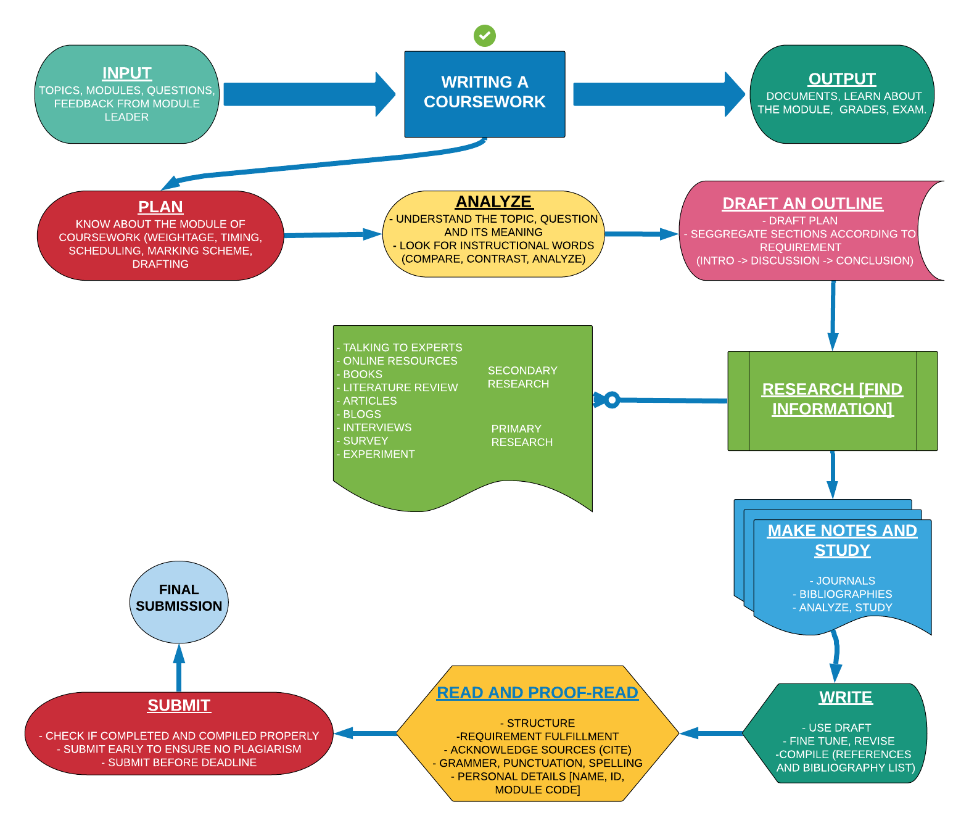

(Lucidchart.com 2019)

Above process flow diagram depicts the process of a coursework writing. Topics, modules, questions, feedback from teacher as input gives documents, grades exam, learning outcomes as output while writing a coursework. Planning, analyzing, drafting, researching, making notes, writing/ taking exams, proofreading and submission are the basic process while writing a coursework.

**DISSERTATION WRITING**

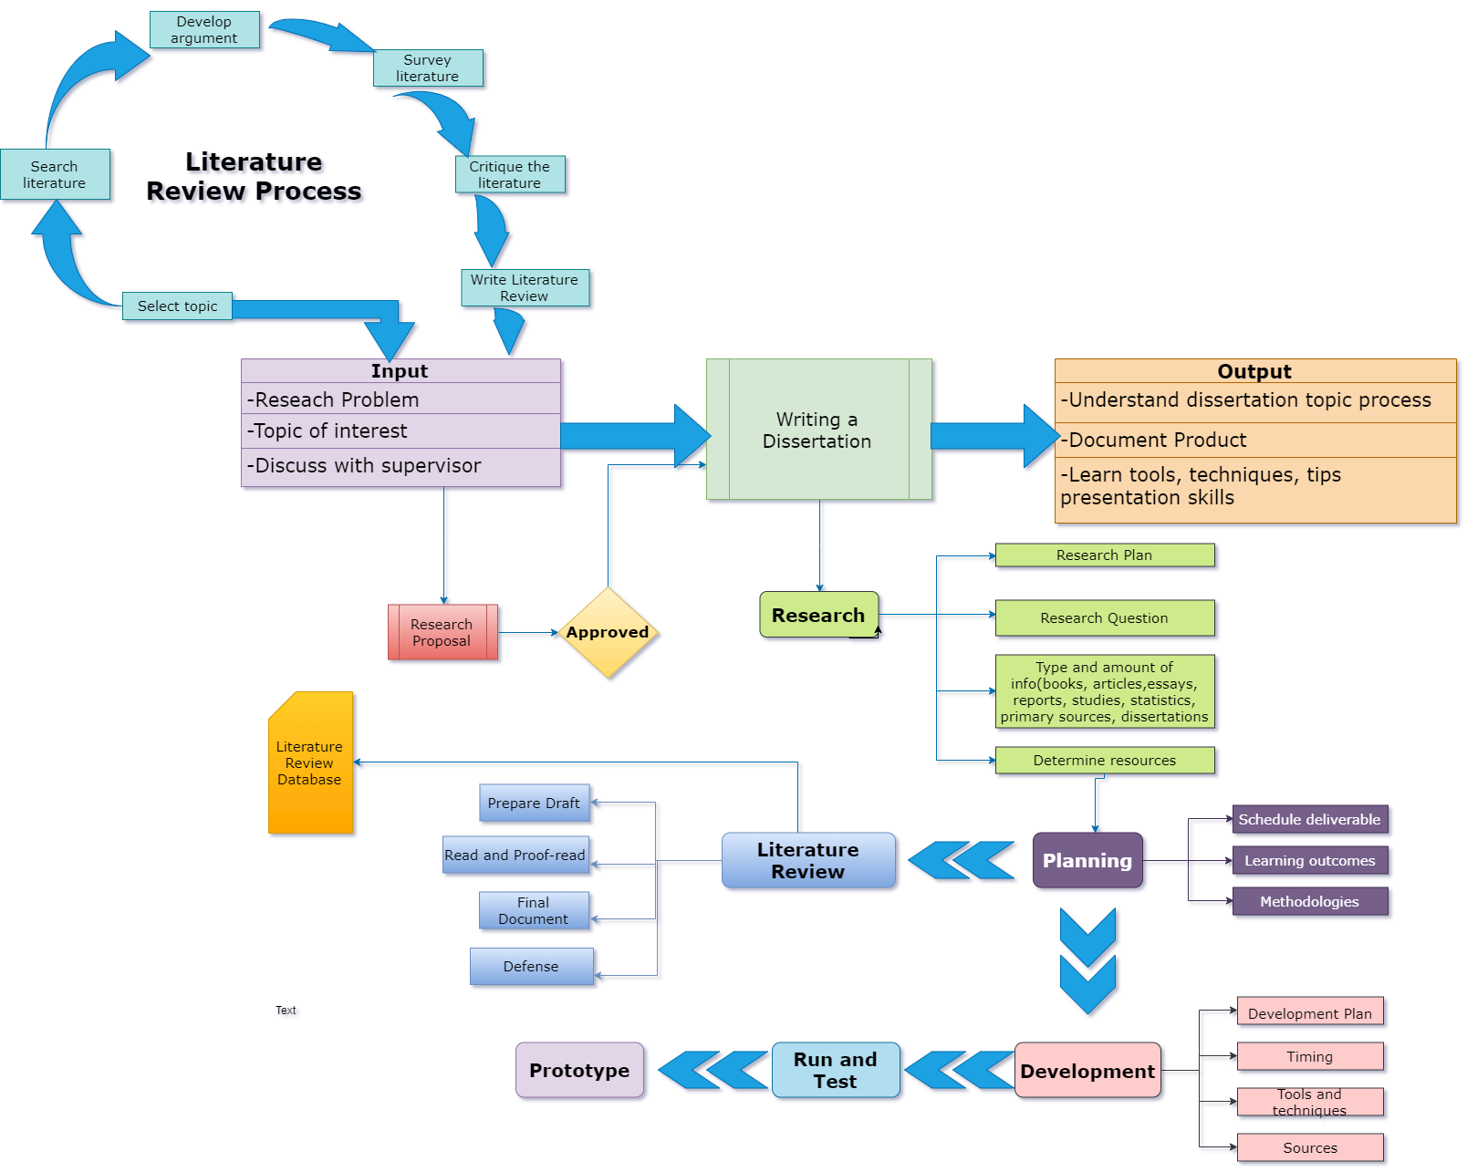

(Draw.io 2019)

Above process flow diagram depicts the process of a dissertation writing. Choosing the topic of interest requires pre literature review to have idea about the topic to carry the research on and to get the input for learning outcome. Like coursework, planning, analyzing, researching, drafting, proofreading are a part of dissertation writing. In addition to that, development of a suitable prototype from the learning process is a part of dissertation writing.

**SIMILARITIES BETWEEN COURSEWORK AND DISSERTATION**

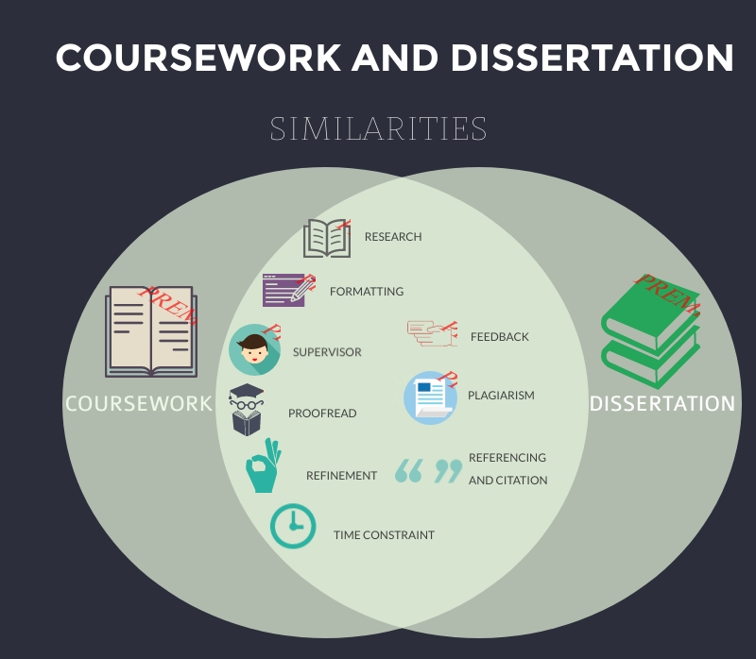

Since both of the topics come under Academic writing, they share some common points between them. Both dissertation and coursework requires some research work however, dissertation requires deep research in the particular topic of interest. Like coursework, the guidance from supervisor aids in research for dissertation writing along with enhancement in knowledge. Both coursework and dissertation requires proofreading, refinement and acknowledgement of the sources. (Biopharma Regulatory Affairs n.d.) Feedback from the module leader in coursework and supervisor in dissertation writing plays vital role in overall progress and development of the assessment. Plagiarism is the key to prove that the tasks done for both coursework and dissertation is unique and self-done. Time constraint is a basic trait to coursework. Similarly, dissertation writing also should be completed within given time frame. While writing either coursework or dissertation, we gain so many skills along the way like communication and time management skills. (Learnhigher.ac.uk 2012)

**DIFFERENCE BETWEEN COURSEWORK AND DISSERTATION**

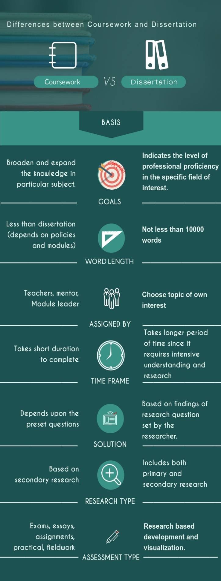

Even though, coursework and dissertation writing come under the same umbrella of academic writing, they differ from each other in various ways. In this case, on the basis of some key points these two are differentiated. For instance, we are given a predefined question to find the solution in coursework. (Learnhigher.ac.uk 2012) On the other hand, we choose our own topic of interest and set research questions by ourselves to carry out the research. A coursework is executed to test a student’s competence and understanding in the subject in field of study giving the opportunity to expand the knowledge like dissertation but the later one requires a more in-depth research than the former one as it aims to show the ability of the writer’s knowledgeability and expertise in the area of study. Coursework is generally short in length than dissertation as dissertation can include both primary and secondary research data, huge amount of literature review, abstract, findings, methodologies and so on unlike coursework where there are predefined length and preset questions to give the solution. So, coursework writing spans semester length whereas dissertation can take more than one semester being the pinnacle of academic excellence (Mustapha 2017)

**BENEFITS OF DISSERTATION WRITING**

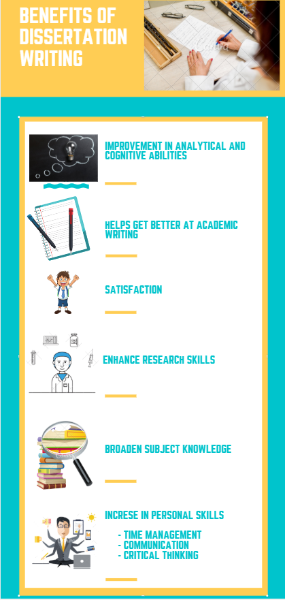

**Improvement in analytical and cognitive abilities**

Analytical skills and imagination assures the usefulness and accuracy of the information we find and use in the assignment. Various aspects of the topic are to be thought and processed carefully that improves the mental abilities. (Anderson 2019)

**Helps get better at academic writing**

Use of right language, approach, proper acknowledgement of the sources is expected in writing. Grammatical and spelling errors are least expected. Writing ability is enhanced during the learning process.

**Enhance research skills**

Research is the key to success in any academic writing. During the process of dissertation writing, we learn and grow by doing plethora of researches on the topic we chose.

**Broaden subject knowledge**

Plenty of research and learning in the process of dissertation writing helps broaden the subject knowledge. It helps understand the topic in depth and with good learning outcomes.

**Increase in Personal Skills**

Dissertation writing helps gain skills like time management skills, communication skills, adaptability (Whittle 2019). We learn to plan and prioritize the tasks depending on deadlines. Frequent consultation with the supervisor for feedback, research, defense of the dissertation helps improve communication skills along with development of critical thinking.

**Satisfaction**

It is a rewarding experience to write a dissertation. We can be proud of the achievements as we carry our own research and collect and analyze our own data. The work done contributes to the current research and also the experience is gained in the field of study. (Wanic 2019)

Both coursework and dissertation writing shares the same set of benefits like improvement in analytical and reasoning abilities, get better at academic writing, enhancement of research skills, personal skills (communication skills, time management skills and adaptability). Unlike the subtle nature of coursework, dissertation gives a sense of belonging and satisfaction to the writer as in-depth research is done alongside frequent visit to the supervisor for feedback and regular work.

**CHALLENGES OF DISSERTATION WRITING**

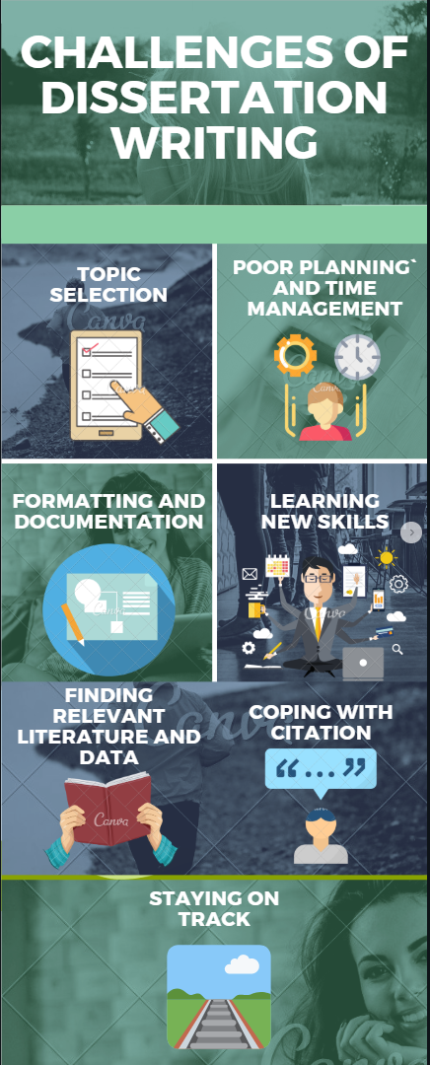

**Topic selection**

Choosing a topic for dissertation writing ensures the research is not too broad that requires too much time, effort and energy. So, working with the supervisor helps craft the material and focus on specific requirement. (Staff 2019)

**Planning and Time management**

The biggest issue between topic selection and defense is the time management. Learning to balance the time in order to achieve the goals is one of the challenges we need to overcome. Procrastinating and getting discouraged on the way doesn’t help the writing process. So proper planning and time management skills helps overcome this challenge.

**Formatting and Documentation**

Another issue while writing dissertation is the proper documentation and formatting. It varies depending upon the policies of the universities or schools. Reviewing, following, proofreading, implementing every rule is hectic task but it is an integral part of the overall dissertation writing.

**Learning new skills**

Learning new skills, technical and non-technical is one of the major challenges to overcome in the process of dissertation writing. Alongside the research of the topic chosen, learning new skills attests to be a challenge. (Lærd Dissertation 2019)

**Finding relevant literature and data**

Literature review section provides comprehensive overview of the information related to the research. It is an important part of the document that makes it more relevant and depicts the depth of research done by the researcher in the process of dissertation writing.

**Coping with citations**

Acknowledging the sources from where the references has been taken must be cited to avoid the issues regarding plagiarism. Endnotes, footnotes, bibliography are included in citations which makes it a cumbersome task. (Pratt 2019)

**Staying on Track**

Once the writing process starts alongside research, planning, develpment and frequent consultation with the supervisor, it becomes difficult to stay on track according to the plan. (OCadiz 2019)

Unlike dissertation writing, we do not need to spend time on literature review and research on the topic selection as coursework has already defined modules and syllabus. We already have enough set of skills to perform the coursework as it is already taught in the classrooms by the mentor however we may need to learn some new skills along the way of dissertation writing. Finding relevant literature and data and staying on is comparatively easier while writing a coursework as it has already predefined set of questions. But challenges like time management, formatting and documentation and coping with citations and referencing are shared by both of the writings.

**CONCLUSION**

Academic writing generally refers to phrases or written forms of description for districts and the respective skill areas which are quite formal, analytical and practical used by researchers / students. Coursework and dissertation writing have some same set of benefits such as developing analytical and reasoning skills, improving scholarly reading, enhancing research skills, personal skills (communication skills, time management skills, and adaptability) however they differ in some ways like finding and staying on relevant literature and information is comparatively simpler as it has already predefined set of questions.